My Target: ____ / 19 or ______ % Complete on the day of the test

🖒 🖓 (Circle when your test is handed back)

**Name: __ Teacher:**

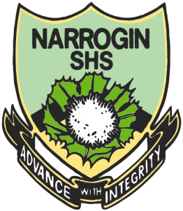

|  |  |  |
| --- | --- | --- |
| Total marks  **/** | **%** | **Weight**  **10%** |
|  |  |  |

Yr 9 Humanites & Social Sciences:

*Civics & Citizenship*

***Task 8 – Key Features of Australia’s Court System***

**PART A: GRAPHIC ORGANISER ASSESSMENT**

**PART B: VALIDATION**

**Total Marks: /19**

1. Types of Graphic Organisers

Use the examples and explanations of each graphic organisers use to help you choose the most appropriate graphic organiser to display a court hierarchy. Number in order of most useful to least useful: one being most useful and four least useful. (4 marks)

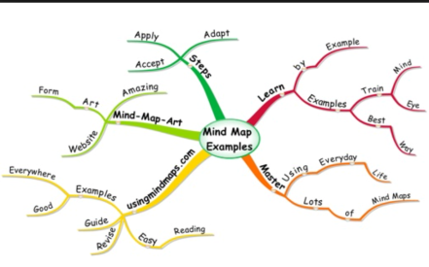

**Brainstorm**

A brainstorm is a graphic organiser that shows a central idea with its corresponding characteristics

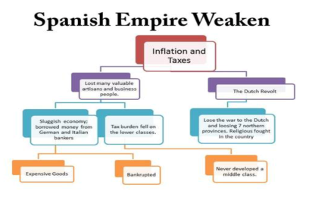**Flow Chart**

A flow diagram or sequence chart shows a series of steps or events in the order in which they take place. Any concept that has a distinct order can be displayed in this type of organizer. A flow chart is excellent for showing the steps necessary to reach a final point.

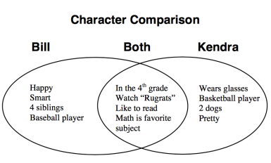

**Venn Diagram**

A compare/contrast or Venn diagram is used to identify the similarities and differences between two or more concepts.

**Hierarchy Pyramid**

List from highest to lowest of importance or a visual

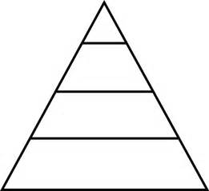

representation displaying proportional value.

1. **Justify** your choice of most useful graphic organiser. A good

Answer will use full sentences. (2 marks)

___________________________________________________

___________________________________________________

___________________________________________________

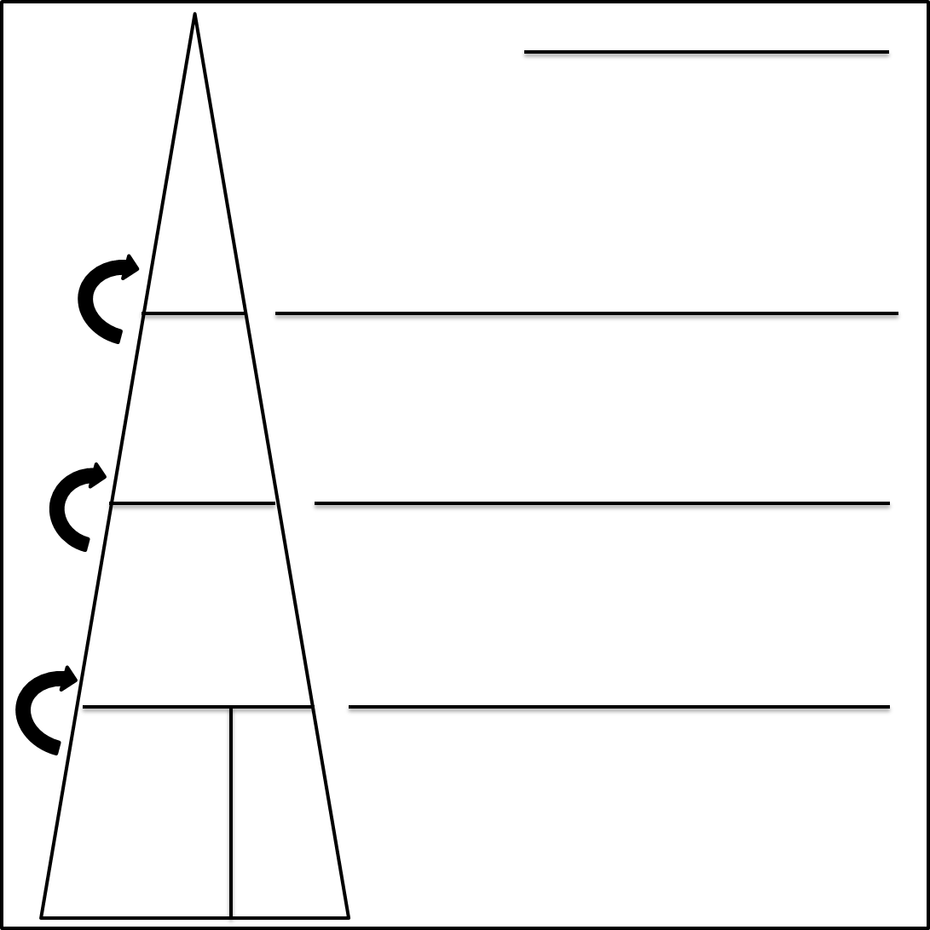

**Name:**

1. **Complete** the graphic organiser on the reverse of this page using the information provided below. Label each level of the hierarchy and choose a key feature and one role of each level to put in the space next to the correct level on the hierarchy. Be sure to label the arrows. (13 marks)

**Australian Court System**

**The Magistrates Court**

This Court makes rulings on minor criminal cases, especially those without a need for a jury such as traffic infringements and theft from someone’s property. These minor criminal cases are also known as ‘summary offences’ or ‘simple offences’. The Magistrates Court can also hear civil cases involving amounts under $75,000.

**The High Court**

The High Court is the last court of Appeal in Australia. It can hear cases on appeal from other courts as well as original cases. This is known as Original jurisdiction. The High Court’s most important role is in interpreting the Constitution and decides whether laws passed act in agreement with the Constitution. It also has a role in resolving disputes between the states. It can hear cases on both Civil and Criminal law. A panel of 7 judges sits on the High Court and they are selected by the federal government.

**The Supreme Court**

This Court deals with the most serious criminal cases such as murder or any offence that carries a life sentence in prison. It also deals with the more serious civil cases involving claims above $750,000. It can hear cases from all the courts below it in the hierarchy, and has a separate court within it called the Appeals division.

**The District Court or County Court**

This Court is also able to deal with serious and complex criminal cases such as armed robbery but not cases such as murder. This is because the court cannot hear matters that impose a life sentence. It can also hear civil cases that medium level and are claims between $75,000 and $750,000.